|  |  |
| --- | --- |
|  | |
|  | |
|  |  |

|  |  |
| --- | --- |
| Publication type: |  |
| Publication number: | ACC |
| Title: |  |
| Subject: |  |
| Issue: | A2.2.10 |
| Publication date: | 10 October 2014 |
| Total number of pages: |  |
| Author: |  |
| Quality Control: |  |

Table of contents

Page #

Figures 4

Tables 6

References 8

Introduction 9

Abbreviations list 9

Safety instructions 10

Revision history 10

1. The basics 11

1.1 Introduction 11

1.2 The mimic page 11

1.2.1 Label 14

1.2.2 Value 14

1.2.3 Symbol 17

1.2.4 Image 20

1.2.5 Icon 20

1.2.6 Pipes 20

2. Special features 23

2.1 Introduction 23

2.2 Sequences 23

2.3 Animation 29

2.4 Tools 30

2.4.1 Introduction 30

2.4.2 Width/height 30

2.4.3 Aligning 33

2.4.4 Copy/paste 34

2.5 Multi-select 36

2.6 Shortcuts 38

3. Assign automation of fields in mimics 38

3.1 Introduction 38

3.2 Export and import object list 38

3.2.1 Export 39

3.2.2 Understand the object numbering 40

3.2.3 Changing possibilities in the object-list 41

3.2.3.1 Label 42

3.2.3.2 Conditions 42

3.2.3.3 Extra fields 42

3.2.4 Import 43

Figures

Figure 9‑1: Mimic icons 10

Figure 9‑2: the mimic page 10

Figure 9‑3: Edit mode 11

Figure 9‑4: Mimic options 11

Figure 9‑5: Mimic option window 12

Figure 9‑6: Label region 13

Figure 9‑7: Label editing 13

Figure 9‑8: Value 14

Figure 9‑9: Value editing 14

Figure 9‑10: Fields window 15

Figure 9‑11: Filled value 15

Figure 9‑12: Color and fill 16

Figure 9‑13: Value editing 16

Figure 9‑14: Symbol editing section 16

Figure 9‑15: Symbol select window 17

Figure 9‑16: Symbol sub-categories 17

Figure 9‑17: 3-way valve symbol 18

Figure 9‑18: Example symbol 18

Figure 9‑19: Image example 19

Figure 9‑20: Pipe example 1 20

Figure 9‑21: Pipe example 2 20

Figure 9‑22: Pipe example 3 21

Figure 9‑23: Pipe example 4 21

Figure 10‑1: Valve open 22

Figure 10‑2: Edit section 22

Figure 10‑3: Valve defective/not available 23

Figure 10‑4: Conditions window 23

Figure 10‑5: conditions tab 1 24

Figure 10‑6: Extra conditions example 25

Figure 10‑7: Tab 2 25

Figure 10‑8: Tab 2 changed 25

Figure 10‑9: Tab 2 conditions 26

Figure 10‑10: Tab 3 settings 26

Figure 10‑11: Tab 4 settings 26

Figure 10‑12: Tab 4 condition 27

Figure 10‑13: Tab 5 settings 27

Figure 10‑14: Tab 5 condition 27

Figure 10‑15: Tab 6 settings 28

Figure 10‑16: Tab 6 condition 28

Figure 10‑17: Animated open 29

Figure 10‑18: Animated closed 29

Figure 10‑19: Tools 30

Figure 10‑20: Icon 30

Figure 10‑21: Tools unchanged 30

Figure 10‑22: Tools changed 30

Figure 10‑23: Icons multiple sizes 31

Figure 10‑24:Icons Selected 31

Figure 10‑25: set multiple size 31

Figure 10‑26: Icons same size 31

Figure 10‑27: Icons aligned 32

Figure 10‑28: Labels 32

Figure 10‑29: Labels adjusted 33

Figure 10‑30: Labels aligned 33

Figure 10‑31:Icons and labels selected 34

Figure 10‑32: Icons and labels copied 34

Figure 10‑33: Icons and labels placed 34

Figure 10‑34: Tools window Copy 35

Figure 10‑35: Copied via tools window 35

Figure 10‑36: multi-select drag 35

Figure 10‑37: Multi-select click 36

Figure 10‑38: select multiple tanks 36

Figure 10‑39: changing multiple items 37

Figure 11‑1: mimic3.txt file in root folder 38

Figure 11‑2: object export list 38

Figure 11‑3: Object-layout 39

Figure 11‑4: Object 0 40

Figure 11‑5: Object 7 40

Figure 11‑6: Changing “FieldTo” 40

Figure 11‑7: Object “7” 40

Figure 11‑8: Label definition 41

Figure 11‑9: Conditions 41

Figure 11‑10: Balloon pop-up 42

Figure 11‑11: Extra fields for an object 42

Tables

Table 9‑1: Mimic options 13

Table 10‑1: Conditions 23

Table 10‑2: Conditions 2 24

Table 10‑3: Shortcuts 37

Table 11‑1: Object export list 39

**NOTICE**

**This document contains proprietary information.**

**No part of this document may be photocopied, reproduced or translated into another language without the prior written consent of   
Free Technics B.V.**

References

Not applicable.

Introduction

The Mimic is the layout where the whole system of NavVision revolves around. Where we use to have static viewers that had a certain amount of gauges statically placed on one screen, now you are free to choose whatever layout in every format you like. You can see the mimic page as a page in a sketchbook. You can draw the layout that you like, alter the looks and colors and make it your own.

There are some restrictions that you need to take care of. Our design department has a long-time experience as well as the knowledge on what is the best way to set-up a good mimic. How do you keep it readable and what is the best way to align mimic pages. In this manual you will find the tools that will help you to make the best mimic pages.

# Abbreviations list

AC Alternating Current

AI Analog IN

AO Analog Out

COM Communication

DI Digital In

DO Digital Out

FT Free Technics

ID Identification  
I/O Input/Output

LAN Local Area Network

Safety instructions

* This section provides only a summary of the safety requirements and notes in the following sections. To protect your health and prevent damage to the AM(C)S equipment or vessel, it is essential to read and carefully follow the safety instructions.*

The indications NOTE, CAUTION and WARNING have the following significance:

* NOTE:  
An operating procedure, practice or condition etc., which it is important to emphasize.*

* CAUTION:*

*An operating procedure, practise or condition etc., which, if not strictly observed, may damage AM(C)S equipment or crash NavVision software.*

* WARNING:*

*An operating procedure, practise or condition etc., which, if not carefully observed may result in personal injury or damage to the vessel.*

Revision history

Revisions issued since publication.

|  |  |  |  |
| --- | --- | --- | --- |
| **Issue** | **Date** | **Revision** | **Reason** |
| 2.1.1 | October 10, 2014 | New version | Decimus update |

# The basics

## Introduction

When you start up NavVision you will find the mimics in the top icon bar under the icon of gauge (see Figure 1‑1). Opening this icon will reveal a few other maps formed like a screen, with a number inside. These icons represent the mimic pages. In the beginning they will probably all be empty so you can click on the first one to start working on the mimic. Don’t worry about the sequence of the mimics, which can be changed at a later time.

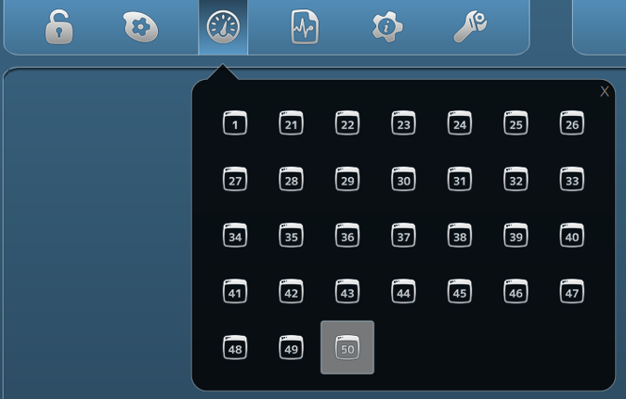

Figure 1‑1: Mimic icons

## The mimic page

The mimic page itself will be an empty page. It is the starting point of the layout that you are going to make (see Figure 1‑2). This page can be altered by right-clicking somewhere on the page and choose “Edit mode” (see Figure 1‑3).

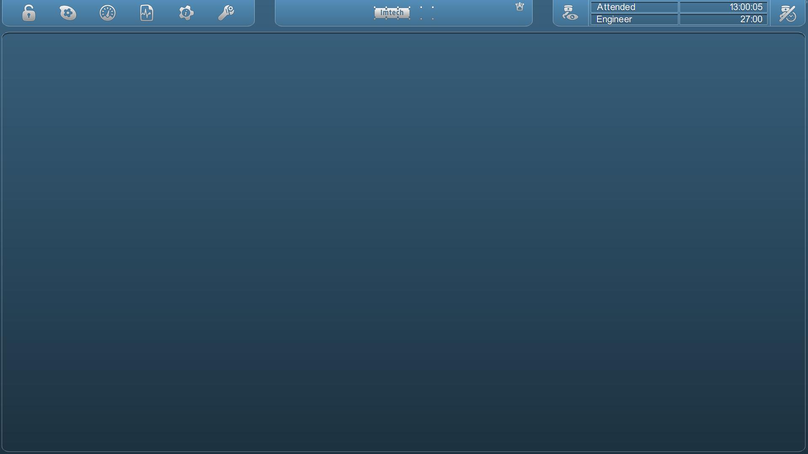

Figure 1‑2: the mimic page

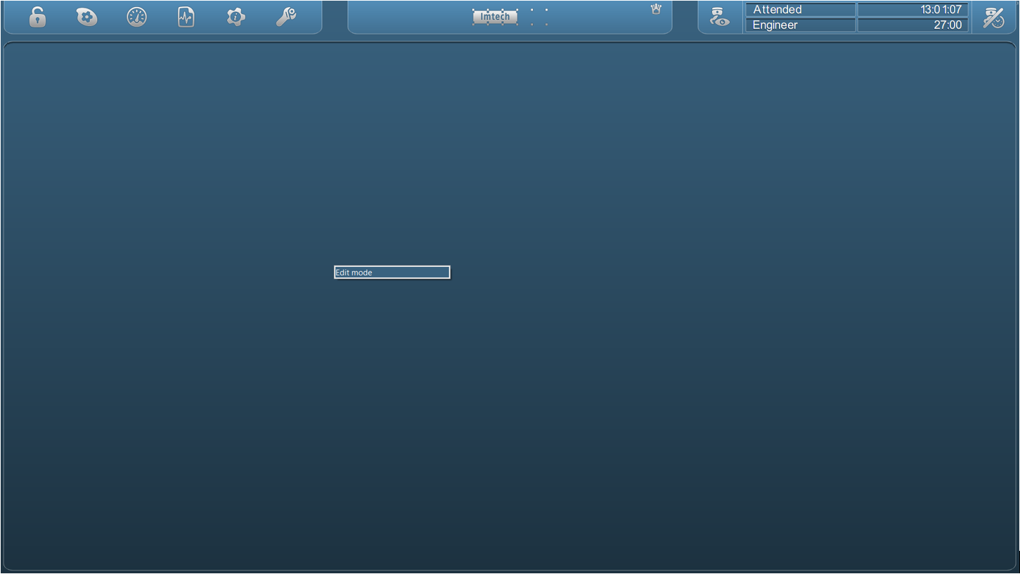

Figure 1‑3: Edit mode

Now the mimic page is ready for changes. You don’t see anything yet, but by right-clicking again, you will get a menu with choices of items that you can place in the mimic (see Figure 1‑4 and Figure 1‑5). Depending on the licenses that you purchased, you can get different options.

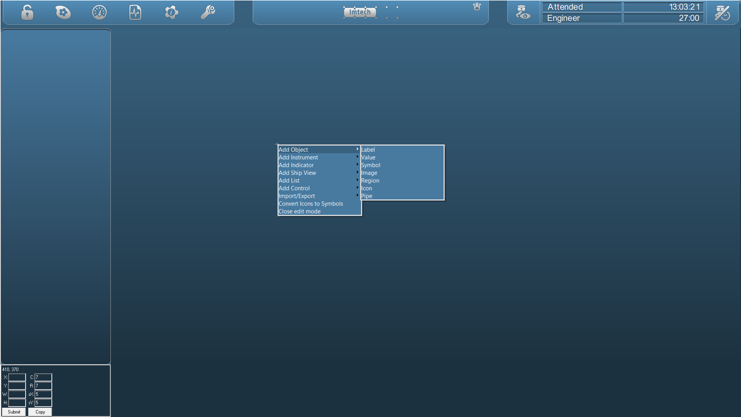

Figure 1‑4: Mimic options

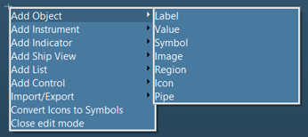

Figure 1‑5: Mimic option window

|  |  |  |
| --- | --- | --- |
| **Choice** | **Option** | **Explanation** |
| Add Object | Label | A Label is a text frame |
|  | Value | Any value that is given by a sensor |
|  | Symbol | NavVision Proprietary Symbols |
|  | Image | Choose any image |
|  | Region | Region to divide separate spaces |
|  | Icon | On/Off icon for indication |
|  | Pipe | Pipes to show ships piping system |
| Add Instrument | Bar | A bar without index |
|  | Horizontal Level | Horizontal Level Bar |
|  | Vertical Level | Vertical Level Bar |
|  | Trend | Trending page (freely adjustable) |
|  | Small Graph | Graphic visualization of data |
|  | DP View | Dynamic view of ship for DP |
|  | Compass | Show compass |
|  | Propulsion | Propulsion view |
|  | Round Instrument | Instrument for data sensors |
|  | Azimuth | View for Azimuth Thrusters |
| Add Indicator | Full | Small indicator mostly for engine data |
|  | Left | Variation on indicator |
|  | Top | Variation on indicator |
|  | Right | Variation on indicator |
|  | Bottom | Variation on indicator |
| Add Ship View | Front view | Front View of Ship |
|  | Side View | Side View of Ship |
|  | Top View | Top View of Ship |
| Add List | Alarm | Alarm Mimic |
|  | Logbook | Logbook Mimic |
| Add Control | Button | Button to trigger events |
|  | Slider | A slider to control settings to any output |
|  | Joystick | Joystick for control |
| Import/Export | Export Object List (assigned) | Export tool for assigning mimic (assigned objects) |
|  | Export Object List (all) | Export tool for assigning mimic (all objects) |
|  | Import Object List | Import tool for assigning mimic |
| Convert Icons to Symbols |  | Convert Icons to Symbols |
| Close Edit Mode |  | Close the editing mode |

Table 1‑1: Mimic options

Before getting into the designing part of the mimics, first let’s address the different mimic options with an example.

### Label

A label is a free to choose text frame. Right-click and choose “Add Label” and then draw a region with your mouse on the place where you want the label to be (see Figure 1‑6). Don’t worry about the exact position or measurement, you can adjust that later. At the bottom of the mimic page you now find a window where you can change the settings for this label (see Figure 1‑7). Here we put a free text in that will be represented in the label region on the mimic page.

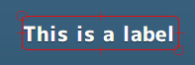

Figure 1‑6: Label region

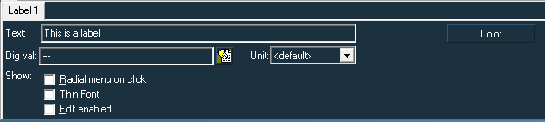

Figure 1‑7: Label editing

Besides the color of the text, you can also choose for a thin font.

If you choose the digital value and leave the text box blank, the label will show the comment of the digital value in the label box on the mimic.

### Value

A value field represents any given value that is coming in to the NavVision system. Same as with the label, choose “Add Value” and draw a region where you want to have this value represented (see Figure 1‑8). Now in the editing window you can choose the sensor of which you want the value to be shown (see Figure 1‑9).

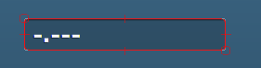

Figure 1‑8: Value

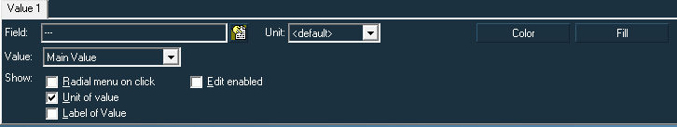

Figure 1‑9: Value editing

By clicking on the drop-down icon next to the field cell, you can choose the I/O you want to use for this value field (see Figure 1‑10).

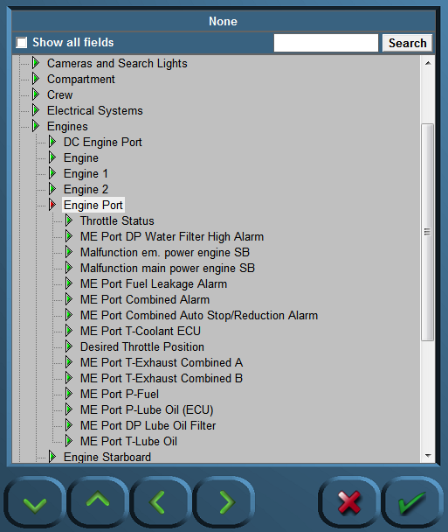

Figure 1‑10: Fields window

Now let’s choose the ME Port T-Coolant ECU field as an example. Click on that field and press the green checkmark. The value-field will look as follows:

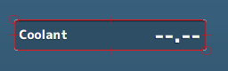

Figure 1‑11: Filled value

*: The place where the value will show in the Value-field can be adjusted by holding the ALT-key and use the arrow-keys to place the value.*

With color you can change the color of the text and with fill you can change the fill of the value-field. See next example for what is possible:

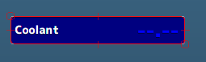

Figure 1‑12: Color and fill

With Value in the editing-window you can choose the representation of the field. Normally you will leave this at “Main Value” especially with an analogue value. But if you, for example want to show an alarm state there (digital value) you can put the value-box on alarm status. This way you get a text that says if the value is normal or in alarm (see Figure 1‑13). For other options we refer to “Software installation and commissioning manual”.

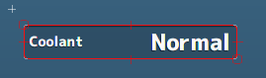

Figure 1‑13: Value editing

Finally you can choose whether to see the Unit of the value (in this case degrees Celsius) and if you want to show the label of the value.

*: most of these options will work the same on the other mimic options. We won’t explain them all in the following chapters while it will suffice to read these earlier mentioned examples. Only the special items will be highlighted.*

### Symbol

A symbol is a proprietary image that belongs to the NavVision system. These symbols are all made by hand for NavVision. These symbols are used to make the visualization easier to understand.

In the options menu choose “Add Symbol” and draw a region. You now will see an empty region. To fill it up you will have to look at the bottom of the screen to the Symbol editing section. See following:

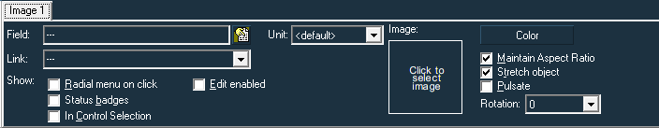

Figure 1‑14: Symbol editing section

Under “Image” you see a square. Click on it and you’ll get the following window:

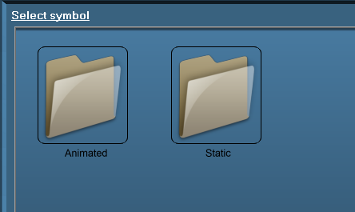

Figure 1‑15: Symbol select window

Here you can choose between the animated- and the static version. We will choose the static folder. In this folder you´ll find all different kinds of sub-categories:

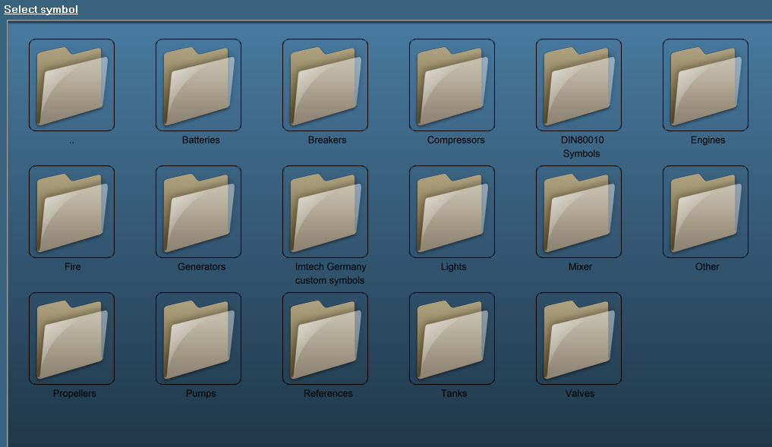

Figure 1‑16: Symbol sub-categories

We choose “Valves” and choose the 3-way valve bottom no fill. So now the region in the mimic will have this valve as symbol:

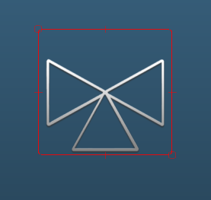

Figure 1‑17: 3-way valve symbol

Now on the right in the editing section you can change some settings for the symbol (see Figure 1‑14). You probably leave “Maintain aspect ratio” and “Stretch object” on. You also can check the “Pulsate” box to make it pulsate and you can change the color and rotation.

Under “field” you can attach a field to the symbol as explained earlier. New items under “Show” helps you to make the symbol more interactive.

Radial menu on click gives a menu where you can select settings for the symbol.

Status badges show information on the status of the symbol.

In control selection gives an extra option to control the symbol.

With these checked, a symbol will look as follows in a mimic:

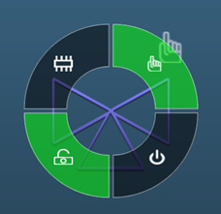

Figure 1‑18: Example symbol

When clicking on the symbol in the mimic a donut will appear with all the possibilities. In this example you can put it to hand or automatic, switch it on and you can see that it is at remote control (padlock is open). More on this will be explained in chapter 2.

### Image

An image is somewhat similar to a symbol with as difference that it can be all kind of images (preferably .PNG). These are often used to place the GA of a ship below the I/O’s etc. This way you will have a clear understanding on where on the ship you can find that specific I/O.

When you select an image it will also be copied to the folder “Layout” in NavVision.

A simple example of an image is the following:

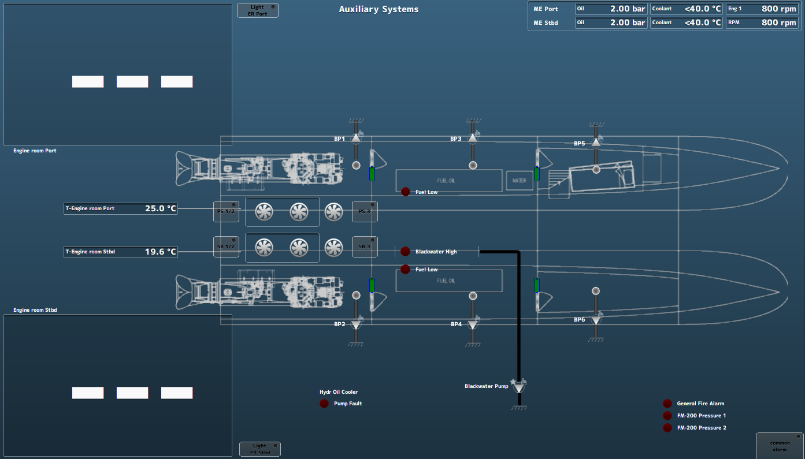

Figure 1‑19: Image example

### Icon

Icons are prepared on/off switches (LED) that you can use easily for alarm purposes or status purposes. When you put in an icon, you can give it a color (red =alarm, green is on/ok) and the icon will go on or off if the sensor is high or low. In Figure 1‑19 you can see a few red icons. Once there is an alarm they will light up red and give you the visual aspect of that alarm on the mimic. Same goes off course for other colors.

### Pipes

Pipes are used for showing the ships piping system. Also it can be used to show a part of the electrical system or even as a separation between items. Pipes can be drawn in all kind of shapes but only horizontal and vertical. As you start with a pipe choose “Add Pipes” in the options menu. Put your mouse on the spot where you want to start your pipe and click. Draw the mouse to the place where the pipe needs to run to and click again. Now you have a line in between these two points. You can do two things. Move your mouse again in another direction (a corner will be made) and click once again when you reach the next place on the mimic. Or, if the pipe is finished, right-click and the pipe will be finished. This way you can draw a line all directions in one piece. See the following:



Figure 1‑20: Pipe example 1

From there on you can start a new pipe or connect a pipe to the existing one. If you want to connect a pipe to an existing one you can start exactly on that pipe and go from there, or you can start somewhere else en end on the existing pipe. See the following:



Figure 1‑21: Pipe example 2

*:the adjacent pipe will fit automatically to the existing one. Only when it has the same thickness and the same color. If you change one of these, the latter will lay above the existing pipe (see* Figure 1‑21*).*

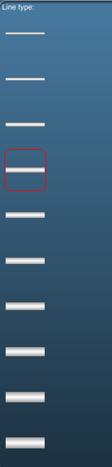

Figure 1‑22: Pipe example 3

In the left side of the menu you can choose the thickness of the line by clicking on the appropriate example (see Figure 1‑22). The color can be changed for the outer- as well as for the inner color so you can comply with regulations (see Figure 1‑23).

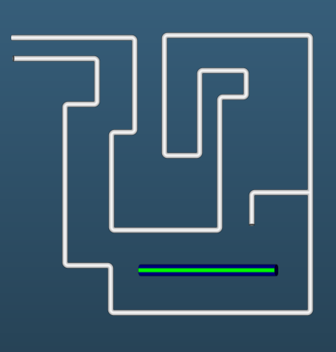

Figure 1‑23: Pipe example 4

In the pipe edit section under “Field” you can attach a field to the pipe, so you can make it interactive again. More on this in Chapter 2.

*: More on color coding, Badges, radial menu items etc. you can find in our manual “Installing and commissioning Manual”.*

# Special features

## Introduction

To make a mimic more interactive there are a lot of features built in to make it even more easy to understand the mimic. There are sequences that you can attach to an object to change this object when several different events occur. There are symbols with animation to make it more readable. And you can make objects interactive with donut pop-ups to start and stop the object and several other things. Thus making it easy to the eye and very understandable.

## Sequences

Sequences are a range of commands you can assign to an object. This makes it visible what that specific object is doing at that specific moment. We will take a valve as example, but it goes without saying that you can use it in various different formats.

Now let’s say you have a fuel valve that you control locally and remote and which has an open- and a closed contact. Of course you would like to see if the valve is open or if it is closed. But you can do more. You can see the time that it is opening or closing in a different format and even have a fail mode to show that the valve is not available.

Let start with drawing a symbol of a valve You will get the following picture:

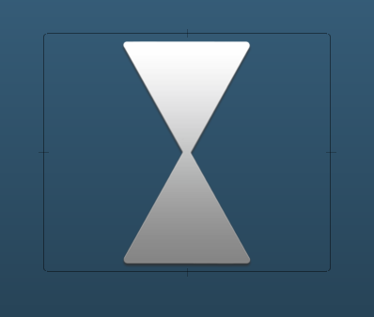

Figure 2‑1: Valve open

Now we will assume for this example that vertical is open and horizontal is closed. First thing we like to do is change the position and the color of the valve symbol for either position. In the edit section you’ll find only one tab in the beginning (see Figure 2‑2). This means that this symbol is always showing. But now we are going to change the sequence.

The first tab is always the last tab the program is looking at. So with several tabs (i.e. 5) it will start to look at tab 4 to see if that is valid. If not it will go to tab 3 and so on. The exception is the highest tab which will only show when all the other tabs are not valid.

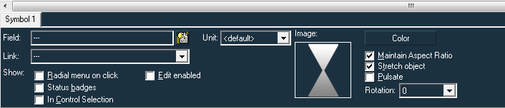

Figure 2‑2: Edit section

We assumed that the vertical position is for open so we should first change the color to green (which is the standard for “open”). But while we also have a defective/not available status (which will be the first in line) we will make this color purple. This will get you the following view:

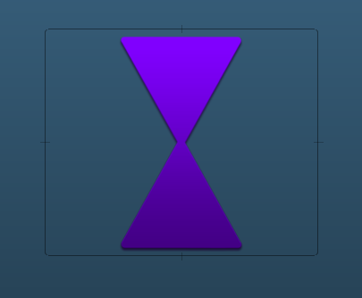

Figure 2‑3: Valve defective/not available

This is not the only thing you need to do. You also will have to alter the conditions of the tab to make it understand when it has to be visible and when not. In the right-botoom corner of the edit section you will find a button “Conditions”. Click it to open a new window that looks like the next picture:

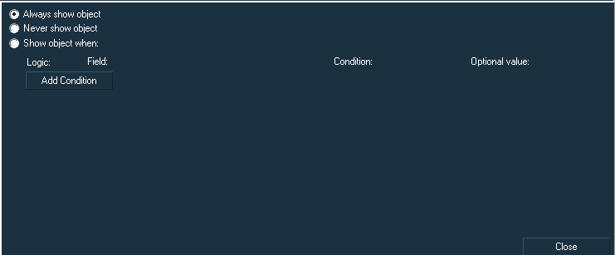

Figure 2‑4: Conditions window

You will see 3 options.

|  |  |
| --- | --- |
| **Option** | **Explanation** |
| Always show object | This object will always be visible, except for when another tab is valid |
| Never show object | Object is never visible |
| Show object when | Shows object when certain thresholds are met |

Table 2‑1: Conditions

The last one is the most used. When you click “Show object when” a few new objects will appear.

|  |  |
| --- | --- |
| **Option** | **Explanation** |
| Logic | Add logic to the equation. (And, Or, And not, Or not) |
| Field | Choose the field as described earlier |
| Condition | Choose the condition the object needs to comply with |
| Optional value | Extra possibilities for some conditions |

Table 2‑2: Conditions 2

So back to our example. We need to add a condition for the first tab. We made the object purple (defective/not available) so we need to add a condition to make this object only available when the valve is defective/not available.

At first we click on the “Show object when” radio-button. Under field we choose the appropriate field (in this case valve 1) and then under “Condition” we choose “defective”. So now we know that this object in this specific configuration will only appear when the conditions are met (see Figure 2‑5).

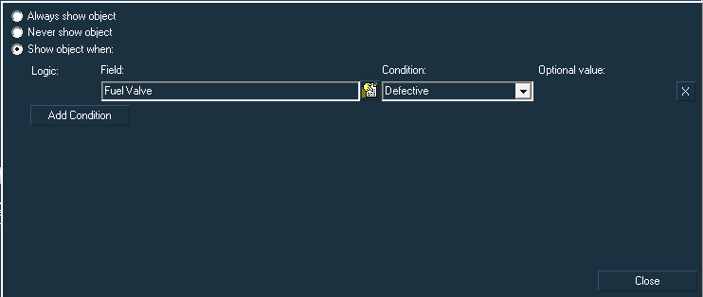

Figure 2‑5: conditions tab 1

As you see there is no logic field nor an optional value field. These only become available when you go a step further. Just for explanation sake let’s assume that you don’t want to show the defective status when the fuel pump is running at low speed. Just click add condition, choose the fuel pump as field and for condition choose “Lower than”. Now you can choose a range at optional value

While the example concerns a Switch-field (which can only be 0 or 1) it will suffice to put 0.5 in the additional field. If it was an analogue field like a RPM or likewise, you can choose the appropriate value.

You get the following:

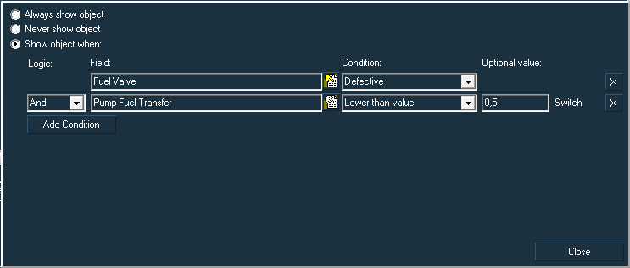

Figure 2‑6: Extra conditions example

Without the extra example, the first tab is finished now. So you can click “Close”. You will see that an extra tab has appeared.

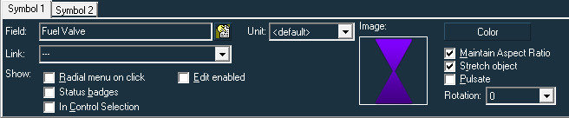

Figure 2‑7: Tab 2

This second tab we will use to show the object has had a request to close. Closed was horizontal and red, so we first need to change that till we get is as in the next example:

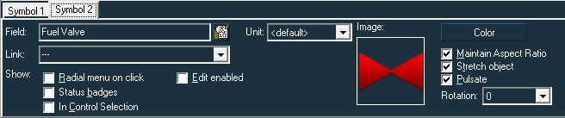

Figure 2‑8: Tab 2 changed

The extra function we added here is “Pulsate”. It has had a request to close, it is not open anymore nor is it closed yet. In this time between two states the object will pulsate to show that it is on its way to close.

We also need the conditions to be changed. This time as condition we will choose show object when Field “Fuel valve” is Condition “Request pending”.

It will look like the following:

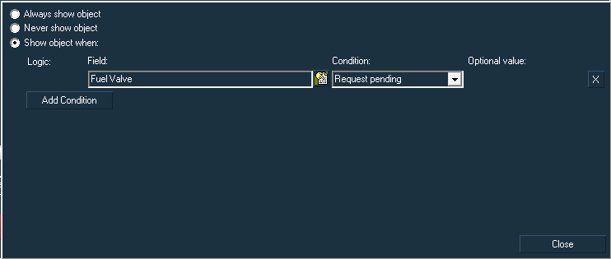

Figure 2‑9: Tab 2 conditions

Now after you click “Close” you will find the third tab.

The third tab will be vertical and green and the condition will also be “Request pending”. Only this time you will choose the vertical, green symbol with pulsate, to show it is on its way to open. It will look like the following:

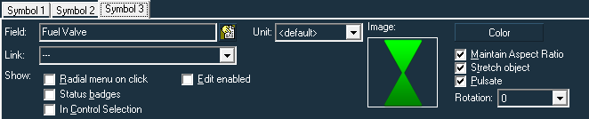

Figure 2‑10: Tab 3 settings

Tab 4 will be horizontal and red without the pulsating. It will show the object when it is closed (See Figure 2‑11).

Under conditions you choose “Off” which is the same as closed (see Figure 2‑12).

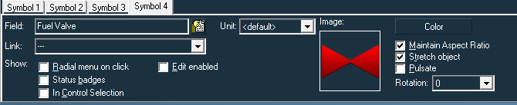

Figure 2‑11: Tab 4 settings

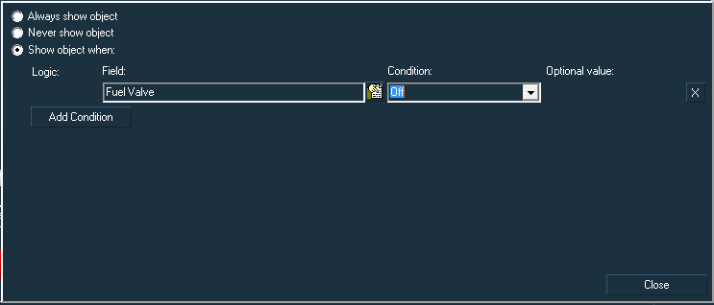

Figure 2‑12: Tab 4 condition

Tab 5 will be Vertical and green without the pulsating (see Figure 2‑13). And the condition will show “On” which is the same as open (see Figure 2‑14).

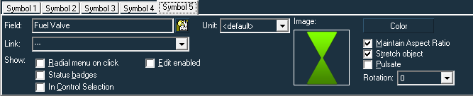

Figure 2‑13: Tab 5 settings

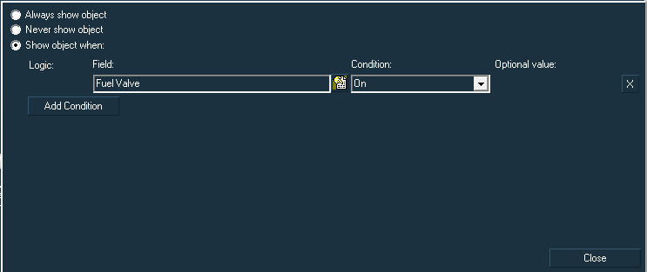

Figure 2‑14: Tab 5 condition

At last after closing this one, you will have the 6th tab. The tab that will allways be visible when none of the other show. We gonna make this white in the open position (see Figure 2‑15). The condition will be “Always show object” (see Figure 2‑16).

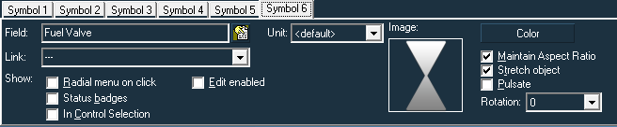

Figure 2‑15: Tab 6 settings

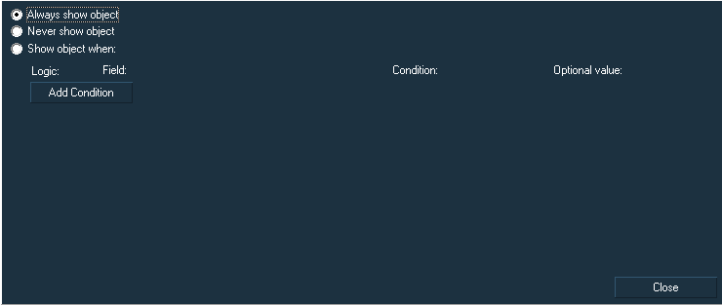

Figure 2‑16: Tab 6 condition

Now you have a full working sequence for the valve. It goes without saying that when you have a lot of valves with the same sequence, first make the sequence, copy/paste the object as many times as you need them and just change the fieldname for each object.

*: This same sequence can be used for images, pipes, etc. Also the order of the sequence can be different.*

## Animation

In FT NavVision© it is also possible to make objects animated. This goes in first instance for the symbols.

As explained earlier you can add a symbol to the mimic. When you choose the symbol you go to the folder “Animated” instead of “Static” (see Figure 1‑15). In this folder you will find a couple of folders with the most common symbols. These Symbols will move, rotate or have another animation’

These animated symbols will come in handy when, for example, you simulate the circuit breaker on a busbar. Together with the conditions you can make this circuit breaker moving and changing color. This will make it yet clearer to comprehend.

So the circuit breaker will go from this:



Figure 2‑17: Animated open

Fluently to this:



Figure 2‑18: Animated closed

## Tools

### Introduction

In the mimic editor there are a view tools to make tasks easier. These tools are meant to make it easier to position an object or copy/position objects. You can also change height and/or width for multiple objects at once.

### Width/height

In the bottom left corner of the mimic (when you’re in edit-mode), there is a square window with a couple of values in it (see Figure 2‑19). These two rows are meant to help you with changing large amounts of objects at once. Let’s take a look at the left column.

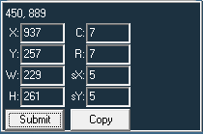

Figure 2‑19: Tools

You will see that the left column has 4 values. X, Y, W and H. These abbreviations stands for

* X-position X-axis
* Y-Position Y-axis
* W-Width
* H-Height

So if you click an object, you can find the position and width and height of that object here. As you can see it has a “Submit” button. You can also change all of these values here.

Let say you have placed an icon in the mimic and you want it to be square. Placing it with your mouse makes the change that it is perfectly square very low (see Figure 2‑20). So you click on the icon (the surrounding square gets red) and go to the tools window. Although it looked quite good, you see at the width and height that it is not perfect (see Figure 2‑21). So change these values to the appropriate size and click submit (see Figure 2‑22). You now have it perfectly balanced.

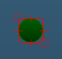

Figure 2‑20: Icon

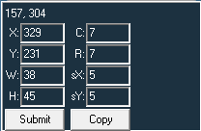

Figure 2‑21: Tools unchanged

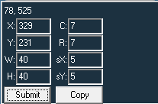

Figure 2‑22: Tools changed

Now let’s say that you have made a bunch of icons that all are different. You want them to be the same. At first it will look like the following:

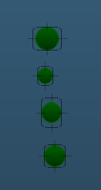

Figure 2‑23: Icons multiple sizes

Just draw your mouse around all the icons to select them all (see Figure 2‑24). And then go to the tools window (see Figure 2‑25). Change the width and height again but now watch out that you clear the X and Y-axis. Otherwise all the icons will be in the same position. Click submit and the result will be that all the icons have the same size (see Figure 2‑26).

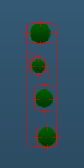

Figure 2‑24:Icons Selected

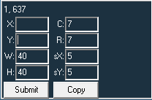

Figure 2‑25: set multiple size

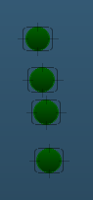

Figure 2‑26: Icons same size

### Aligning

Now in the previous example the icons are not well aligned. NavVision also has a tool for that. First select the icons again as in Figure 2‑24 and then press ALT-Left arrow. The icons will all be aligned with the left side as base, see next figure:

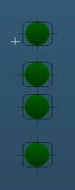

Figure 2‑27: Icons aligned

The vertical alignment in this example has to be done by hand or in the tools window by position. Because these are the first objects in the mimic, you won’t have a reference.

As you go on from here, you can align in all directions. Let’s put a label behind each icon. Right-click and choose “Add label”. Place the label somewhere and change the name in the edit section to “Icon1”. Do the same for the other 3 icons. You will get a picture as in the following figure:

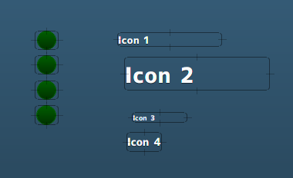

Figure 2‑28: Labels

First make all the labels the same size. It works best if you make the height of the labels the same as the icons because it will fit the best then. See following figure:

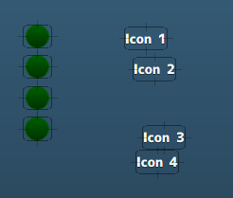

Figure 2‑29: Labels adjusted

Now select the upper icon and the upper label (draw your mouse around them or click on the icon and CTRL-click on the label) and press the CTRL-key together with the up-arrow. Do the same for the other icons and labels. Finally select all labels and press CTRL Left-arrow to align the labels. You now will have all the icons and labels aligned. See following:

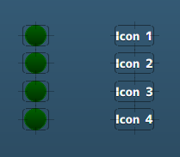

Figure 2‑30: Labels aligned

You can always move a selected object by using the arrow-keys. So if you want to bring the labels closer to the icons, just select the labels and use the left-arrow key to bring them together.

### Copy/paste

If you need multiple editions of an object you can use copy/paste. From the last example with the icons we assume that we need another set like this. Select the icons and labels by dragging your mouse around it (see Figure 2‑31). Now press CTRL-C and after that CTRL-V to copy and paste the selection. The copied part will appear just on top of the original (see Figure 2‑32). Drag this with your mouse to a new position (see Figure 2‑33).

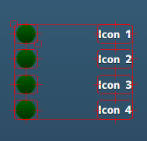

Figure 2‑31:Icons and labels selected

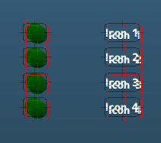

Figure 2‑32: Icons and labels copied

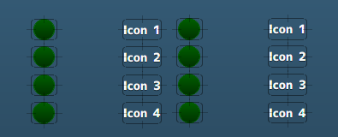

Figure 2‑33: Icons and labels placed

If you need a lot of copies you can use the tools window. The right column is for copying single or multiple objects.

* C-Columns
* R-Rows
* sX-pixels X-axis shift
* sY-Pixels Y-axis shift

So if you want to copy the icons and columns and you need 4 columns and 3 rows With a shift of 10 pixels. You select the icons and labels and change the values like shown in the next figure:

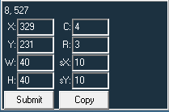

Figure 2‑34: Tools window Copy

Press “Copy” and you get the copied icons and labels as in the following figure:

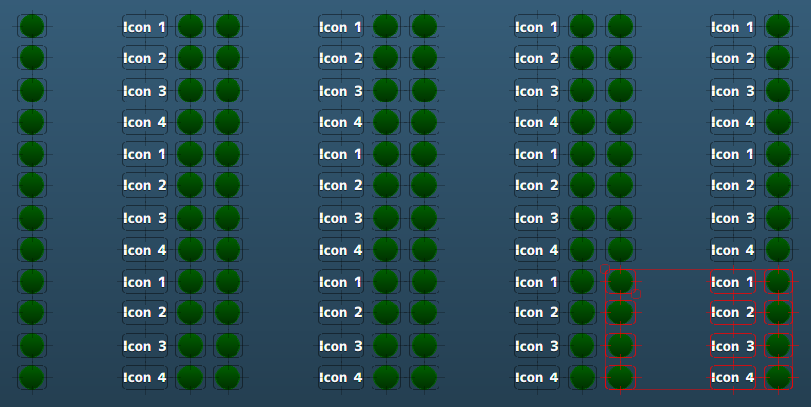

Figure 2‑35: Copied via tools window

*: This applies to all objects. Take notice that after copying the labels and fieldnames of the icons has to be changed by hand.*

## Multi-select

If you need to add or subtract some features to multiple items in a mimic, you can do this by multi-select. There are two ways that you can select more than one item:

* Click the right mouse button and hold it down while you drag over the items that you want to select.

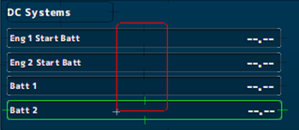

Figure 2‑36: multi-select drag

* Click on the first item that you want to select. Then hold down CTRL and click on the other items that you want to select.

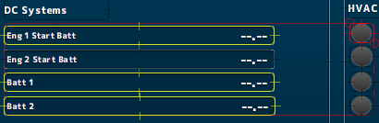

Figure 2‑37: Multi-select click

Once you have selected all the items that you need, you can apply all kind of actions on multiple items at once. For example, you can make them all pulsate, give them all the same Field tag, change color and all the other things you find in the setup section at the bottom of the mimic screen.

Let’s say that we want to change a couple of tanks at the same time. In this case we drag and select all the tanks. See following picture:

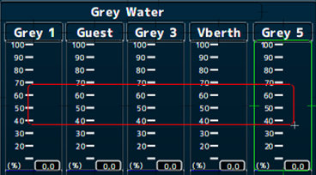

Figure 2‑38: select multiple tanks

Once all selected, we can change color, add label, etc. In this case we see they are all grey water. The color should be grey then. With all these tanks selected we go to color and choose grey. Now we have changed the color for all tanks into grey.

This goes for all the changes you can make. Another small example: in Figure 2‑38 you can see that the tanks show their value in %. If you want to change that to Litre, you just change the unit with all tanks selected and it will change for all tanks as you can see in the following picture:

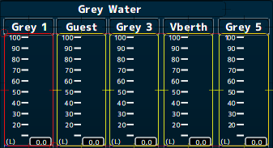

Figure 2‑39: changing multiple items

*: Also conditions can be set for multiple items. Just select multiple items as described and follow the steps in this chapter.*

## Shortcuts

There are a few shortcuts in the mimic layout that are very usable. We discussed already a few, but we will sum them up here for your convenience.

|  |  |
| --- | --- |
| **Shortcut** | **Explanation** |
| CTRL-Numpad + (i) | Zoom in |
| CTRL-Numpad - (o) | Zoom out |
| CTRL-Arrow keys | Align a group of objects in the arrow-key direction |
| CTRL-Shift-Arrow keys | Align object left-center-right or top-middle-bottom |
| Arrow-keys | Move object in arrow-key direction |
| CTRL-X | Copy selected |
| CTRL-V | Paste Selected |
| CTRL-Z | Go step back |
| CTRL-Y | Go step forward |
| Shift-Arrow keys | Align pipes and other objects to fit |
| Alt-Arrow keys | Align text and values in labels and value regions |
| CTRL-G | Show grid |

Table 2‑3: Shortcuts

# Assign automation of fields in mimics

## Introduction

If a mimic is finished you have the design ready. The next step is that you assign NavVision fields to the objects in the mimic to make it work. You can do that piece by piece as described in earlier chapters. However, when the mimics get more complicated, this means a lot of work. For that purpose we have tried to automate a lot of that work.

## Export and import object list

When you go into edit mode and right-click to see the options menu, at the bottom you will find 3 lines that pertain the import and export options for the objects.

* Export Object List (Assigned)
* Export Object List (All)
* Import Object List

If you click “Export Object List (Assigned)” it will export a list (*.txt) for all the objects that are currently assigned.

If you click “Export Object List (All)” it will export a list (*.txt) for all the objects.

If you click “Import Object List” it will import a list (*.txt) into the NavVision mimic that you are working in and overwrite all the settings you have changed.

### Export

When clicking Export, whether it is assigned or all, it will make a *.txt file in the root of the NavVision directory. Depending on which mimic you are in, the file will get a name like mimic1.txt, mimic2.txt, etc.

This file in the NavVision root directory you can open with excel. As example we take a random mimic and exported all the objects. In our case it was mimic 3 so we are looking for mimic3.txt.

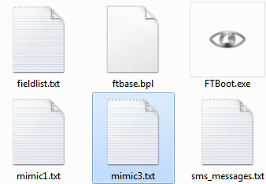

Figure 3‑1: mimic3.txt file in root folder

By right-clicking on the file and choose for “open with…” and then Microsoft Excel, the file will be opened in Excel. It will look like the following figure:

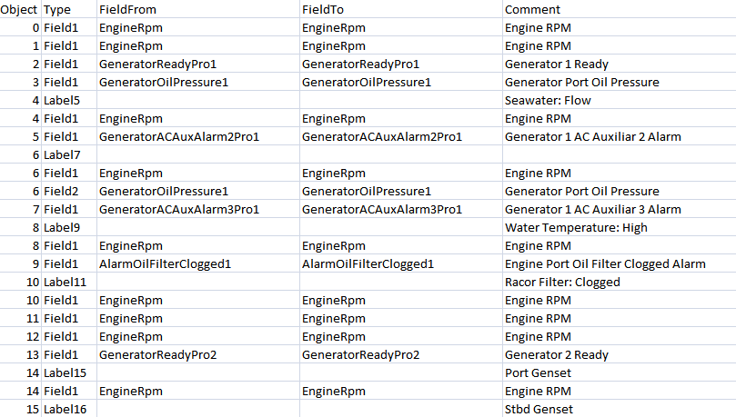

Figure 3‑2: object export list

|  |  |
| --- | --- |
| **field** | **Explanation** |
| Object | Number of the object on the mimic |
| Type | Kind of object (Field, Label, Condition etc.) |
| FieldFrom | The current attached field tag |
| FieldTo | Here you can change the field of the object |
| Comment | The comment of the field in FT NavVision© |

Table 3‑1: Object export list

### Understand the object numbering

To understand which object has which number, you need to do an extra thing. You need to print the mimic. When you are on the mimic page (not in edit mode) hold CTRL-Shift and press “P” This will print the object-layout of the mimic. You can print it on paper, but also to a PDF-file, whatever you find easier.

The object layout will look like the following figure:

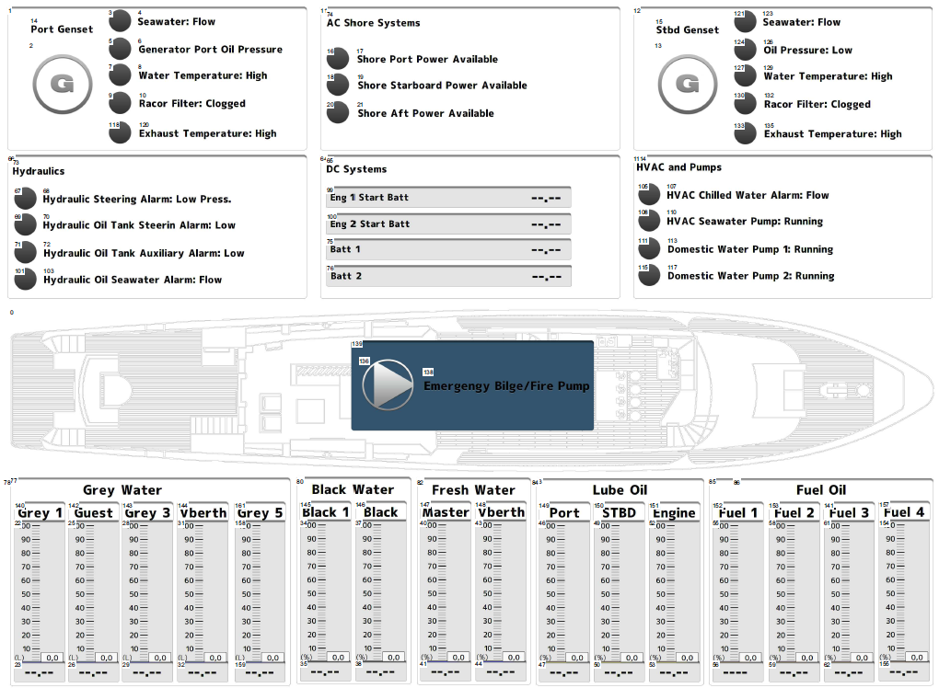

Figure 3‑3: Object-layout

You can see that every object has its own number now in correspondence to the object export list. If we zoom in you can see that in correspondence to Figure 3‑2 object “0” is the image of the ship (see Figure 3‑4) and object “7” is the icon for “Water Temperature: High” (see Figure 3‑5).

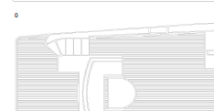

Figure 3‑4: Object 0

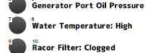

Figure 3‑5: Object 7

So by checking the object numbers, we can change the field id in the column “FieldTo” in the “Object export list”.

So for object “0” we know that it is an image and it does not need a field id from NavVision . the fieldto-cell can be empty, see following:



Figure 3‑6: Changing “FieldTo”

*: leave the “FieldFrom” as it is cause NavVision needs to know what it was before to change it.*

Obect “7” now has a generator auxiliary alarm field as field id (see Figure 3‑7). This can be good if we have chosen that before. In the comment-column you see the comment as it is set in fieldsettings in NavVision. If you want to change this you need to change that in the sensorlist or in NavVision fieldsettings.



Figure 3‑7: Object “7”

This way you can change everything in the list until you are satisfied and after you have imported the list again, you now that everything will be assigned accordingly.

### Changing possibilities in the object-list

In the type-column you can see and change the kind of object you want to change. Every object (except labels) have a field1. This is the main field where you can assign the NavVision field id that you want to be represented there. There are a few exceptions that we will discuss next.

#### Label

Labels are a kind of name tag for an object like an icon, or just a text to clarify things. It is not yet possible to change these using the export list. However, if you don’t use the text but instead take the digital value for that label, the object will show the comment from that field id. And we can change that to whatever text in NavVision or through the sensorlist. The pro with that is, if you change the field in the sensorlist, the text in the label will change automatically with it. For a label it will look like the following:



Figure 3‑8: Label definition

You’ll notice that we don’t use the text value but instead just use Field1 for object8 here. This results that in the label the comment of Field1 will appear (in this case “ Engine RPM” ).

#### Conditions

In the export list all conditions of an object will appear as well (see Figure 3‑9). The first condition will only show if the field id is different than the field id of the object. Of course now you can change the conditions the same way as described before. Also if you didn’t put in conditions before, you can add them by adding some empty rows and add the conditions by hand.



Figure 3‑9: Conditions

#### Extra fields

Sometimes a mimic is so crowded that you can’t show all the fields you like. Sometimes you just do not want all the information directly on your mimic. For that purpose NavVision developed a balloon-like pop-up (see Figure 3‑10). This can be added by defining more fields for the same object and fill them with the field id that you want to see there (see Figure 3‑11).

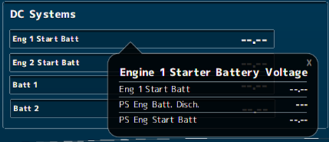

Figure 3‑10: Balloon pop-up



Figure 3‑11: Extra fields for an object

*: To see those extra fields, double-click on the object in the mimic and the balloon will appear.*

### Import

Once you have adjusted everything you will have to save the *.txt file. Just close excel and it will ask you if you want to save the changes. Click “yes”. You will be asked if you want to override the existing file, again click “yes”. All other pop-ups you get you can answer with “yes” or “OK”.

Once the file is saved, go back to your mimic. Go to edit mode and right-click to get all the options. Choose “Import Object List” and answer “yes” to the pop-up. Now your adjusted object list will be implemented in the mimic. Check if everything is working as planned.

*:If you are going to make changes again, don’t forget to make an export again first or you will still have the old *.txt file.*